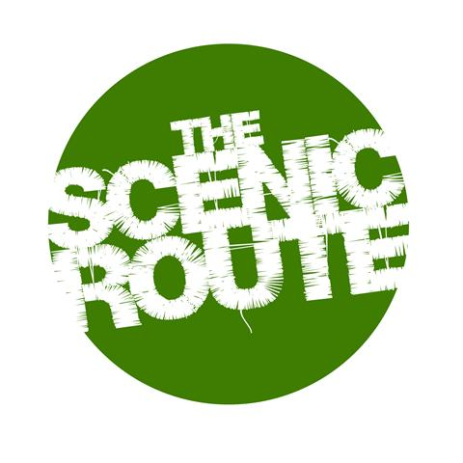
Application for Creating Theatre: An Intensive Lab

Please complete and return to info@scenicroutetheatre.co.uk
along with any additional documents / links / files you feel may be relevant

(Selection will be via this application form and considered on the basis of putting together a group we believe will work effectively collaboratively and represent a range of interests and creative pathways. We are looking for commitment, and genuine interest, there is no requirement for previous experience)

Name:
Date of birth:
Address:
Email:
Contact Number:

In what way/s would you describe yourself as a theatre maker? (Or your interests as a future theatre maker?)
Please elaborate on any previous relevant experience or interests and feel free to forward a CV / videos / media / links etc

What interests you about the lab and devised theatre in general, and what would you hope to gain from the course?

Where did you hear about this course?

Thank you for your application.

We will be in touch as soon as possible.

